ELECTROCHEMICAL CORROSION OF METALS

Most of the metals in the nature occur in form of compounds. These might be oxides, sulphides, carbonates, or other complex compounds. The fact that most of the metals can be found in nature in the form of compounds expresses some natural regularity. The preparation of pure metal needs to invest a lot of energy and sorry to say, but soon the pure metal spontaneously changes back to a compound.

By the thermodynamics the corrosion is a process to reach the minimum energy level. According to the thermodynamics the spontaneous processes are taking place if the free energy change (ΔG) is negative, i.e., the Gibbs free energy of the final state is lower than the initial one. The sign of the free energy change gives only the thermodynamic potential of the process, and tells us nothing about the speed of the process. The corrosion protection techniques in many cases are rate limiting processes because the corrosion itself is thermodynamically possible.

The corrosion of metallic structural materials can be classified into the following categories.

- Chemical corrosion. On the metal surface purely chemical transformation are taking place, which have a significant mass loss. In practice of mechanical engineering, this type of corrosion occurs in such fuel oil firing which contains vanadium compounds. The protective oxide layer formed on the heat exchanger is continuously dissolved by the precipitating vanadium compounds.
- Stress corrosion. Also known as fatigue, this can result in weakening the cohesive forces between the metal crystals. This type of non-chemical corrosion, a detailed discussion will take place within other objects.
- Electrochemical corrosion. The most common types of corrosion discussed in the followings.

ELECTROCHEMICAL CORROSION
Corrosion process occurs during the equalization of electrochemical potential difference. The part of processes accompanying the equalization take place in space separated way which may be in order of nanometres and meters. The potential difference in electrochemical corrosion means energy difference expressed in voltage

The electrochemical potential difference between the metal and its solution containing own ions can be calculated by the Nernst equation.
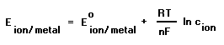
where E _{ion/metal} : electrode potential E ⁰ _{ion/metal} = standard electrode potential
R : universal gas constant T : temperature
F : Faraday constant c : concentration of metal ion
n : charge number change accompanying the metal to metal ion transformation
The potential difference between two places can be expressed by the following equation:
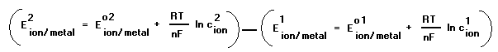
On the base of equation potential difference can be formed, if
- there are two different metals or there are same metals but with different crystal structure,
( E⁰ ²_{ion/metal} and E⁰ ¹_{ion/metal} differs from each other)
- there is a temperature difference between the same metal,
( the metal and the ion concentration is the same except the temperature)
- there is a concentration difference between the same metal.
( all parameters are the same but there is a concentration difference in solution contacting ….the two metals)
The corrosion process caused by potential difference occurs only in certain conditions existing simultaneously, so the necessary and sufficient conditions of electrochemical corrosion can be formulated as follows.
- Existence of two places having different electrode potential connecting in metallic contact.
- The two places having different electrode potential must be covered by electrolyte.
- The presence of depolarizer
The realization of the first condition may occur if two metals or alloys are in metallic contact. Concentration difference or bending (distortion of metallic crystal structure) also causes potential difference on metal surface.
The second condition requires the presence of aqueous solutions which contain moving ions. Easily dissociating salts (NaCl, Na₂SO₄, etc).
The third point needs a bit more explanation. The corrosion is actually dissolution of a metal e.g. the iron goes to solution.
Fe = Fe²⁺ + 2 e⁻
The process involves loss of electrons, i.e. oxidation. The oxidation processes in the electrochemistry are called anodic processes. However, oxidation alone can not be achieved; there must be a process that uses the generated electrons. This process is an electron taking up, i.e. reduction. Name the electron taking up process is cathodic reduction. Any material which promotes corrosion of the anodic process by taking up the electrons are called depolarizer. In mechanical engineering practice, the vast majority of electrochemical corrosion can be due to the presence of three depolarizers (hydrogen ion, dissolved oxygen and dissolved elemental chlorine), These materials ensure the reduction process for the anodic dissolution, i.e., corrosion.

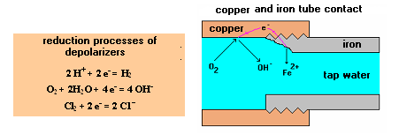
The above mentioned tree conditions are significant from the point of corrosion prevention.
In lack of any of the three conditions there is no corrosion. Central heating systems are typical example. These heating systems are nearly closed systems, so after the dissolved oxygen is used up by the corrosion and there is no replacement, the corrosion stops despite the fact that the heating water (generally tap water) is an electrolyte and the copper tube is in contact with the aluminium or iron plate radiators.
The next drawing (Fig.1) shows the standard electrode potentials of some metals and depolarizer, which help to understand the processes of corrosion.

1. Figure. STANDARD ELECTRODE POTENTIALS OF SOME PROCESSES

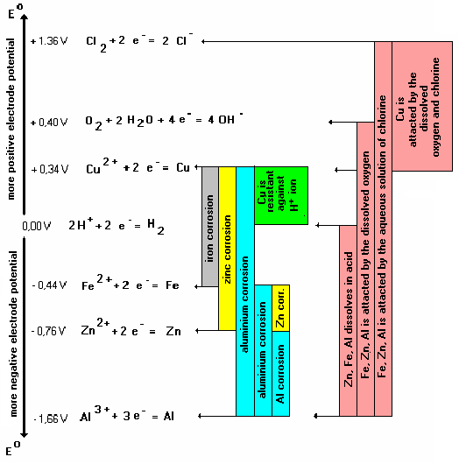
CORROSION DAMAGE IF TWO METALS ARE IN CONTACT
In case of pure metals the standard electrode potential table can be used to guess which metal will corrode. The general rule is that always the metal having more negative potential corrodes. Check on the diagram that if copper is in contact with Al. Zn, Fe, always the letter will be corrode.

WHICH METAL CORRODES IN WHICH SOLUTION ?
If the metal itself immerse a solution, it will corrode if the electrode potential of the metal is more negative than the potential of the possible reduction process in the solution. For example, iron immersed in hydrochloric acid will be corroded because the iron has more negative potential ( Fe = Fe ⁺⁺ + 2e ⁻ ) than the possible reduction process in the acid ( 2H⁺ + 2e⁻ = H₂ ).
THE DISSOLVED OXYGEN IS ONE OF THE MOST DANGEROUS DEPOLARIZER
Based on the potential conditions (Fig.1.) it can be concluded that the dissolved oxygen can attack a lot of metals having more negative potential (Al, Fe, Zn).

HOW TO BUILD TWO DIFFERENT METALS TOGEATHER?
In many cases, we can not avoid the contact of two different metals. In this case we have to minimize the potential difference between the metals by appropriate material selection. The next rule is that the greater surface structural material must have more negative potential, i.e. it will be the anode. The corrosion of high-surface material will lead to a much less corrosion damage expressed in [mm/year] than on a small area.

CORROSION AT NON-STANDARD CONDITIONS (E.G. ALLOYS IN ANY ELECTROLYTE)
We can draw conclusion about the corrosion susceptibility of metals from the table of standard electrode potentials if the metals are pure. In practice, however, generally alloys are used in mechanical engineering practice, and the metals or alloys may contact with any kind ionic solutions.
However, the rule – the metal having more negative potential will always corrode - is always valid. Due to the large number of alloys and aqueous electrolyte solutions there are almost endless variety, so tabular data are rarely available. In this case, there is no other option than to measure the potential difference.
In case of two metals or alloys sufficiently large samples must separately immerse into a solution, which will likely come into contact with them. Measuring the voltage difference between the two metals the size of potential difference [V] measured by the voltmeter will be proportional with the corrosion driving force. The sign of the measured potential difference determines the metal to be corroded (Fig.2.).

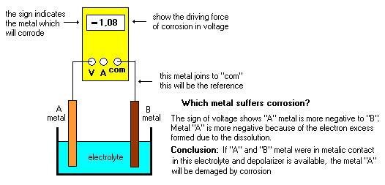
Fig.2. Determination of corrosion possibility by voltage meter

If a large number of metals or alloys are going to be examined in a given solution, it is advisable to measure the electrode potential of each metallic material with respect to a reference electrode having constant potential (e.g. saturated calomel electrode “SCE”). The calomel electrode basically serves the same purpose as in the measurement of the standard electrode potential by standard hydrogen electrode, but it is much easier to use). The tabulated results can be used to estimate the corrosion properties of the alloy construction. The alloy with more negative potential tends to be corroded.

APPROXIMATE DETERMINATION OF THE CORROSION RATE IN [mm / year]

Two metal-based sample immersed into any liquid (electrolyte) the rate of corrosion can be estimated measuring the electric current between the two metals and the surface of anode after the steady-state processes. The metal having more negative potential becomes the anode (anode: metal = metal + + ne⁻), while the other will be the cathode. In acidic solution in the cathodic process: (2H ⁺ + 2e⁻= H₂), in neutral solutions, the reduction of dissolved oxygen dominates: (O₂ + 2 H₂O + 4 e⁻= 4 OH⁻).
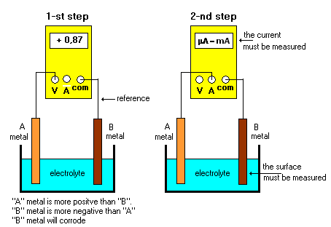
Fig.3. Approximate determination of corrosion rate
The measurement is not accurate, because the measured current depends on the distance of the two metallic samples (preferably put close together), the corrosion rate will not be uniform (in each other facing surfaces show faster corrosion rate) and the equilibration takes often considerable time.

CALCULATION OF CORROSION RATE [mm/year]

The calculation assumes that the measured current is constant during one year. The amount of metal went into solution can be determined by the Faraday law:

atomic mass of dissolving metal
m = k * I * t where k = --------------------------------
(z*F)
where m : mass of metal went into solution [g]
k : metal dependent Faraday constans [g/Ah]
I : corrosion current [A]
z : charge of the metallic ion went into solution
F : Faraday constant 26,8 [Ah]
t : duration of the corrosion process [hour]

The calculated mass (m) is the amount of metal went into solution during one year on the surface immersed into the electrolyte [g/year].

This amount must be recalculated on 1 m², so we get the rate of corrosion v_{corr} in [g/(m²year)] unit
m[g/year]
v_{corr} = --------------
A [m²]
where A : the surface of dissolving metal in the electrolyte.

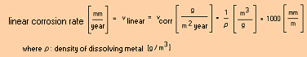

Review questions:
1. What types of corrosion do you know?
2. List the necessary and sufficient conditions for the electrochemical corrosion?
3. What is the role of depolarizer in the electrochemical corrosion?.
4. Write the anode process and a possible cathode process of the iron corrosion.
5. Write the anode process and a possible cathode process of copper corrosion.
6. Does the dissolved oxygen attack the copper pipe?
8. Give the anode and cathode process of the corrosion of copper in waving sea water.

JOB SUMMARY
Determination of corrosion potentials
Measure the electrode potentials of various metals and metal alloys compared to calomel electrode (reference electrode) in the prepared electrolyte.
- Write down the type of electrolyte, measure the temperature.
- Place the metal to be measured in the electrolyte and the reference electrode (calomel).
- Measure the electrode potential between them by a multimeter one minute after the loop linking.
- Read the measured value with correct sign and note with proper unit.
- Remove the metal from the electrolyte, wash and wipe it dry.
- Repeat the measurement with a new metal.
The measurement results must be sorted by bar chart on graph paper, respectively. Be sure to give a title for the diagram, indicate the parameters that influence the measurement results, but do not change during the measurement. Assign proper unit to values ​​on each axes.

Determination of corrosion rate
Measure the expected corrosion rate of two different metals in contact with a given electrolyte.
- Select two metal sample and immerse both into the prepared electrolyte.
- Measure the electric current accompanying the corrosion process between the two metals by the multimeter properly connected . (The measured current continuously decreases after the start of the measurement, and then stabilize.) After approximately two minutes, record the measured current in proper unit. (See Fig.2.)
- Identify using the potentials obtained during the previous measurement data, that which metal will be expected to suffer corrosion. Verify the results the multimeter.
- A measure the metal surface, which is expected to suffer from corrosion.
Calculate the corrosion rate [g/m²year] and [mm/year] in units.

Content of the report
- A description of the measurement in a way that anyone can repeat it from your report.
- Summarizes the measured data in table.
- Attach the potential diagram drawn to the report.
- Clearly, describe the progress of the corrosion rate calculation.

